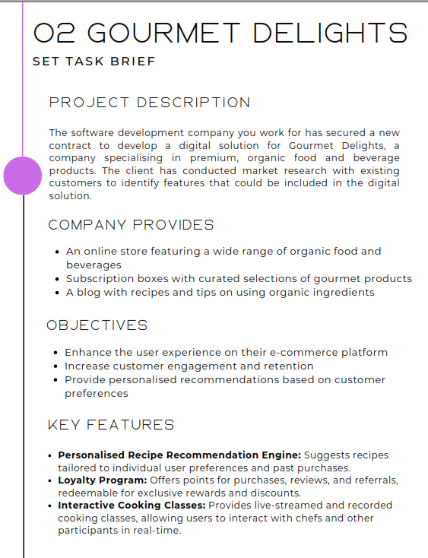
Proposal for Gourmet Delights
1. Project Overview
Gourmet Delights aims to improve how customers discover, purchase, and engage with premium organic food and beverage products by introducing a modern digital platform. The goal is to make organic shopping easier, more personalised, and more enjoyable by offering tailored recipe suggestions, exclusive loyalty rewards, and interactive cooking experiences. The upgraded system will increase customer engagement, enhance user experience, and build long-term brand loyalty.
To support this, Gourmet Delights plans to enhance their e-commerce platform with new digital features that help users browse products, access useful cooking tips, and receive personalised recommendations based on their tastes and past purchases.
The proposed digital solution will include:
• Personalised Recipe Recommendation Engine
Suggests recipes tailored to individual preferences, dietary needs, and previous orders.
• Loyalty Program
Offers points, discounts, rewards, and referral bonuses to increase engagement and repeat purchases.
• Interactive Cooking Classes
Live-streamed and recorded cooking classes allowing users to engage with chefs and other participants in real time.
These features directly support Gourmet Delights’ mission of improving the customer experience through personalisation, quality service, and exclusive organic offerings.

2. Problems Identified
Problem 1 – Lack of Personalised Shopping and Recipe Support
Current product listings and recipes are not tailored to users’ dietary preferences, favourite flavours, or order history, resulting in inconsistent engagement.
Problem 2 – Limited Incentives for Customer Retention
Customers lack strong reasons to make repeat purchases due to the absence of a structured loyalty program or rewards system.
Problem 3 – Weak Engagement Beyond Standard Shopping
The platform does not currently provide interactive experiences, such as cooking classes or guided recipe content, which reduces long-term user engagement.

3. Proposed Solutions
Solution to Problem 1 – Personalised Recipe Recommendation Engine
A system that uses user preferences and past purchase data to recommend recipes and products that suit their tastes.
Solution to Problem 2 – Loyalty Program
A reward system where users earn points for purchases, reviews, and referrals, redeemable for discounts, exclusive products, or early access.
Solution to Problem 3 – Interactive Cooking Classes
A feature enabling users to join live or recorded cooking sessions, interact with chefs, and improve their cooking skills using organic ingredients.

4. Decomposition of Solutions
Personalised Recipe Recommendation Engine
The engine collects information about user preferences, dietary needs, past purchases, and browsing behaviour.
It then automatically generates recipe suggestions and product pairings that match the customer’s profile.
Users can save their favourite recipes, filter suggestions, and update their preferences at any time.
Loyalty Program
The system tracks points earned through activities such as purchases, reviews, and referrals.
Users can view their points balance, redeem rewards, and receive exclusive offers.
The platform will also include tiered membership levels, encouraging consistent engagement.
Interactive Cooking Classes
Users can browse upcoming classes, join live sessions, and watch recorded content at their convenience.
Live classes allow real-time interaction with chefs through chat and Q&A.
Classes will include downloadable ingredient lists, step-by-step guides, and links to related products in the online store.

5. Client and User Needs
Gourmet Delights’ main goals are to improve customer experience, increase retention, and provide personalised recommendations based on user preferences.
• New customers need clear navigation, simple recipes, and quick access to organic product information.
• Returning customers need personalised recommendations and a loyalty system that recognises their engagement.
• Users with dietary needs require tailored recipes and filters for allergens or specific ingredients.
• Food enthusiasts need interactive features, such as cooking classes, to deepen their engagement with the brand.
To meet these needs, the platform should include personalised recipe suggestions, an engaging loyalty program, interactive classes, and a fully accessible interface.
These features will enhance the e-commerce experience and strengthen customer loyalty.

6. Mitigating Potential Risks
Personalised Recipe Recommendation Engine
Validation checks will prevent inaccurate preference data. Algorithms will be tested to reduce incorrect or irrelevant recommendations.
User Accounts
All account data will be encrypted. Password resets, MFA, and login alerts will prevent unauthorised access.
Loyalty Program
Fraudulent point accumulation will be minimised using automated detection. Reward redemption logs will track suspicious activity.
Interactive Cooking Classes
Streaming issues will be reduced through stable hosting and CDN support. Backup recordings will prevent content loss.
Moderation tools will keep chat features safe during live classes.
Technical Reliability
Cloud hosting, autoscaling, and regular backups will reduce downtime and ensure smooth performance.

7. Security & Compliance Risks
Security Features
All personal and purchase data will be encrypted in transit and at rest.
MFA, RBAC, and routine security audits will ensure strong system protection.
The platform will comply with GDPR requirements and meet WCAG accessibility standards.
Legal Requirements
• Equality Act 2010 – ensures accessibility for all users.
• Consumer Rights Act 2015 – requires accuracy in recipe and product information.
• GDPR – governs the collection and processing of customer data.
• Copyright laws – apply to recipes, video content, and cooking class materials.

8. System Requirements
Functional Requirements
• Secure user account system
• Personalised Recipe Recommendation Engine
• Loyalty Program with point tracking and reward redemption
• Access to live and recorded cooking classes
• Ability to browse, favourite, and save recipes
• Simple e-commerce navigation with product filtering
Non-Functional Requirements
• 99.9% uptime
• Strong encryption and data protection
• Fast loading times
• Scalable architecture for high-traffic events (e.g., live classes)
• Full WCAG accessibility compliance

9. Key Performance Indicators (KPIs)
• Recommendation Accuracy: At least 90% relevance based on user feedback within four months
• Customer Engagement: 30% increase in recipe interactions and profile updates within six months
• Loyalty Program Participation: 20% growth in reward redemptions
• Page Load Time: Under 2.5 seconds for all e-commerce and recipe pages
• System Uptime: 99.9% availability
• Customer Retention: 15% increase in repeat purchases within six months

10. User Acceptance Criteria (UAC)
Personalised Recipe Recommendation Engine
Must produce relevant, accurate recipe suggestions and allow easy updating of preferences.
Loyalty Program
Users must earn points reliably, redeem rewards without errors, and clearly view their activity history.
Interactive Cooking Classes
Streams must run smoothly, recordings must load correctly, and users should be able to access class materials easily.
Navigation
All features should be accessible within three taps, with consistent layouts and full screen-reader support.

